“Where we found APlaceInTheSun.com.”
15 November 2008
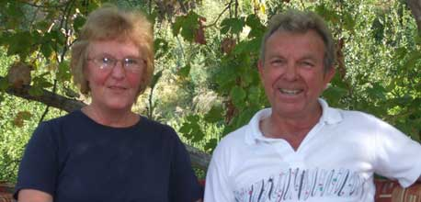
Just two months after the launch of APlaceInTheSun.com, the first couple to buy a property found within the site’s property search listings have signed on the dotted line.
Sixty-somethings Dave Patterson and Marion Allen from Minehead in Somerset spotted their two-bedroom apartment in Akkaya, near Dalaman, on APlaceThe Sun.com and got in touch with agent David Russell of Country Properties
“Due to poor returns on our investments in the UK, we decided to put our savings into a buy-to-let property overseas,” Dave says. “We have had several holidays to Turkey which we very much enjoyed. We love the country, and the apartment is close to Dalaman, which is useful for the airport.”
“At £52,500, the apartment is very good value for the money we had to invest. It’s being built in an area that’s very appealing to us – full of nature.”
Dave and Marion hope to spend as much time as possible at their new home between October and May each year to escape the bitter British winter and will also welcome family and friends.
David Russell, overseas manager for Country Properties, says he was able to show Dave and Marion around the property himself.
“This was our first development in Turkey and when I saw the Akkaya site with my colleague, we instantly decided to market it,” he says. “I was so impressed that I bought a semi-detached villa on the nearby lakeside development in the same Akkaya area. The Akkaya gardens project was launched off-plan in summer 2007. I happened to be at my villa when Dave and Marion came to Turkey and was able to show them around.”
“Dave loved the top floor apartments with their stunning views of the lake, and we provided him with an indication of possible rental income which suggests £450 a week in high season would be achievable.”
The apartments are located in a very tranquil, quiet area that is just 20-minutes from Dalaman town. The development includes a small shop and bakery, a restaurant and is set in an area of outstanding natural beauty. Plans are currently being presented for a nine or 18-hole golf course.

