The economist
the Ekonomist (Equavilent of Times Magazine in Turkey), Dalaman was declared as a 1st degree Tourism Region in the West Coast of Turkey. The new Tourism Project of Dalaman consists of a Marina, Golf Courses, brand new International Airport accessible from UK and Europe, New tunnel to Gocek Marina,which is now open and many other developments which were planned extensively in the Tourism Project.
Also, Adventure Parks, Hobby Gardens, Organic agriculture centers, Education Centers, Recreation centers, Water Sports, Thermal Hotels, Boutique Villas, and Health and Beauty Centers will be included in the project.  The total estimated value of the project is 18 billion and 3 billion Dollars of the whole Project is allocated for infrastructural developments. The project is due to be completed in 5 years. The total Bed capacity in Dalaman will be 75.000. Therefore, the unemployment level of Dalaman will be much lower than the unemployment level of Turkey. | 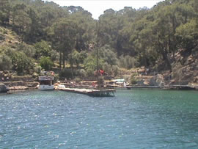
The first phase of the investment in the Tourism Project will be opened to investors in 2008. The aim of the project is to increase the quality of tourism in Turkey by making Dalaman a Healthy Living City in the Tourism sector. The main focus of the Dalaman Tourism Project is to attract the American, European and Gulf Countries investors’ to Dalaman.
In recent years, as golf courses with international standards have opened up, Turkey has become an elite golfing centre where players from around the world can meet in an environment of quality and prestige. Especially the area of Belek, 30km east of Antalya, where, there is a potential for golf tourism with the unique bonus of the cultural, historical and natural sightseeing of the region. Top-class courses are also being planned for Istanbul, Ankara and Mugla.
In Turkey, most courses are in the vicinity of tourist resorts, around the coastal regions which have the necessary facilities like accommodation, restaurants and entertainment. The Ministry of Tourism plans to establish another 6 golf courses in these tourist areas. stage.

